RESULTS
3.1 Fluorescence measurements
FPE was incubated for 60 minutes with Jurkat T lymphocytes. Figure 3.1a shows the resulting emission spectrum of FPE.
FIG 3.1a
The emission spectrum of FPE. Jurkat T lymphocytes in sucrose buffer (280mM, pH 7.5) were incubated at 37ºC with FPE, and the emission spectrum obtained. The peak emission is at 518nm.

The peak emission wavelength of FPE was observed to be 518nm. This results from electrons in the molecule returning to their ‘ground state’ (S₀) from the first ‘excited state’ (S₁). This same method was used to ascertain the peak excitation wavelength, which is the wavelength required to raise electrons in FPE from S₀ to S₁. The peak excitation wavelength was observed to be 490nm (data in Appendix). These results were used when setting the parameters of the spectrometer’s monochromators.
To observe the action of FPE, calcium chloride (CaCl₂) was added to Jurkat T lymphocytes that had previously been labelled with FPE. In solution, this molecule dissociates to it constituent ions and consequently, positively charged calcium ions (Ca²⁺) would be drawn towards the negatively charged membrane surface. As previously described, this would increase the electrostatic surface potential (Ψ). This would alter the protonation state of the acidic FPE molecule, causing it to fluoresce [Wall et al, 1995b]. (See Figure 3.1b).
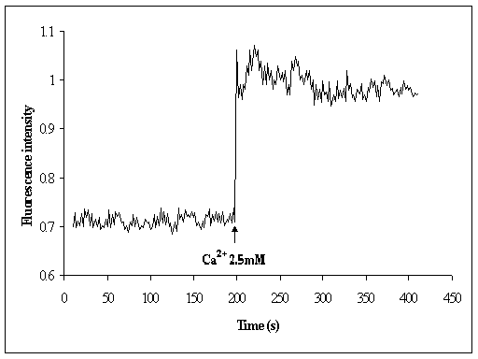
FIG 3.1b
The interaction of Ca²⁺ with FPE-labelled Jurkat T lymphocytes. 2.5mM Ca²⁺ was added to a suspension of approx. 10,000 FPE-labelled Jurkat cells in sucrose buffer (280mM, pH 7.5) at the time indicated by arrow. The excitation wavelength was set at 490nm, and the emission wavelength set at 518nm, in accordance with previous results. Temperature was maintained at 37ºC.

The response of FPE to the addition of calcium ions proved that the FPE labelling method used to label the Jurkat cells was sufficient, and also that the FPE responded in the way expected. Previous experiments have used a calcium ionophore (A23187) to demonstrate the function of FPE [Wall et al, 1995a]. The ionophore takes up Ca²⁺ ions and transports them across the cell membrane into the cell. If calcium is introduced to cells using this method, there is no change of the fluorescence of FPE observed. This proves that FPE is only inserted into the outer leaflet of the lipid bilayer.

3.2 Interaction of gp41_{FD} with FPE-labelled T lymphocytes
A hydropathy plot [Kyte & Doolittle, 1982] shows that the fusion domain of HIV-1 gp41 consists of 16 hydrophobic amino acid residues (See Figure 3.2a). When exposed, the hydrophobic gp41_{FD} molecule will interact with the hydrophobic lipid bilayer of T cell membranes.
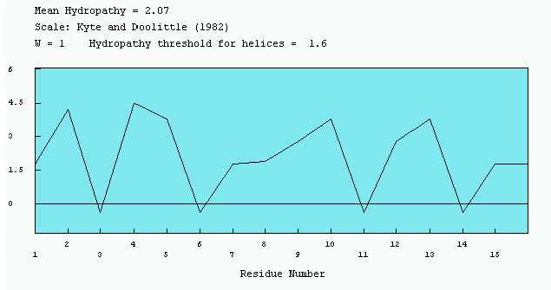FIG 3.2a
Hydropathy plot for HIV-1 gp41, using the Kyte and Doolittle scale (1982). All residues are hydrophobic, with a mean hydropathy of 2.07.

Stopped flow analysis was used to observe the change in fluorescence of FPE-labelled Jurkat T lymphocytes over time. The samples enter the reaction chamber at the same time. As the binding reaction takes place in the first few milliseconds but insertion takes longer (1-10 seconds), a split time-base was used. This enabled both the initial binding reaction and the later fusion reaction to be analysed in similar detail. Figures 3.2b + c show the change in fluorescence when 30μM of gp41_{FD} was added to a suspension of FPE-labelled Jurkat T lymphocytes.
An increase in the fluorescence of FPE can be seen over the first 0.1 seconds of the reaction. The positively charged gp41_{FD} molecule is located near the T cell membrane, thus causing a change in the electrostatic surface potential (Ψ). The protonation state of FPE is altered, and the intensity of fluorescence increases (See Figure 3.2b).
FIG 3.2b: Interaction of HIV-1 gp41_{FD} with FPE-labelled Jurkat T lymphocytes at 37ºC. This shows the initial binding reaction over the first 0.1 seconds. The initial decrease in fluorescence intensity is the ‘lag phase’. This is the time taken for the gp41_{FD} and the FPE-labelled cells to enter the reaction chamber and mix.

As the gp41_{FD} inserts itself into the T cell membrane, the intensity of fluorescence of FPE decreases (See Figure 3.2c). As FPE only inserts into the outer leaflet of the lipid bilayer, the charged molecule inside the cell has no effect [Wall et al, 1995a]. The Ψ of the cell membrane and the protonation state of FPE return to normal, and a decrease in the intensity of fluorescence of FPE is observed.
FIG 3.2c: Interaction of HIV-1 gp41_{FD} with FPE-labelled Jurkat T lymphocytes at 37ºC. This shows the insertion reaction over approximately 10 seconds.

The effect of sequential additions of HIV-1 gp41_{FD} on Jurkat T lymphocytes was also analysed. As expected, with each addition of peptide, the intensity of the fluorescence of FPE increased accordingly (See Figure 3.2d).
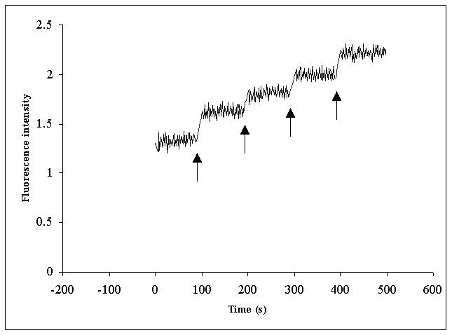FIG 3.2d
Sequential additions of HIV-1 gp41_{FD} to FPE-labelled Jurkat T cell membranes. Additions of 5μM gp41_{FD} were added to a suspension of approximately 5,000 Jurkat T cells labelled with FPE in a sucrose buffer (280mM, pH 7.5), at times indicated by the arrows. Excitation wavelength was set at 490nm, and emission wavelength was set at 518nm.

Within the concentration range of gp41_{FD} examined in this assay, the level at which the T cells were fully saturated was not reached. It is known that at concentrations above 30μM, peptide aggregates form in the suspension causing an increase in signal ‘noise’ [Cladera et al, 1999]. At low concentrations of peptide, the hydrophobic gp41_{FD} molecules enter the lipid bilayer to move away from water molecules, until the membrane is saturated. After this point, the gp41_{FD} molecules clump together to form hydrophobic aggregates. These peptide masses can pass in front of the spectrometer beam and scatter the signal. It is therefore difficult to determine the saturation point of cell membranes, since the formation of aggregates at high concentrations makes it hard to read the results accurately.

3.3 Analysis of sequential gp41_{FD} additions
From the results obtained from the sequential addition of gp41_{FD} to FPE-labelled Jurkat T lymphocytes (Figure 3.2d), it was possible to analyse the reaction occurring when the fusion peptide binds to the T cells. Hyperbolic and sigmoidal curves (See Figure 3.3a) were fitted to the points (the increase in fluorescence was plotted against the concentration of gp41_{FD}, after being corrected to account for light-scattering) using equations 1 and 2 (see Materials and Methods). The hyperbolic curve did not fit the data well, and is therefore not shown. The r² value (indicating the quality of the fit to the curve) for the sigmoidal equation was (0.997) i.e. fits the data well. This curve also had a lower standard error (0.025), indicating that the sigmoidal curve was the better fit to the data. This implies that there is a degree of cooperativity for the binding of gp41_{FD} to T cells. The Hill coefficient for the curve was 2.17, which suggests that there are more than two molecules involved in the binding of gp41_{FD}. A similar outcome was reported by Cladera et al (2001), although this data yielded a Hill coefficient of almost 3, suggesting that a trimeric complex of gp41_{FD} is responsible for binding to the T lymphocyte membrane surface. Despite a lower value for the Hill coefficient, the result 2.17 would also suggest a trimeric complex (i.e. more than two molecules involved).

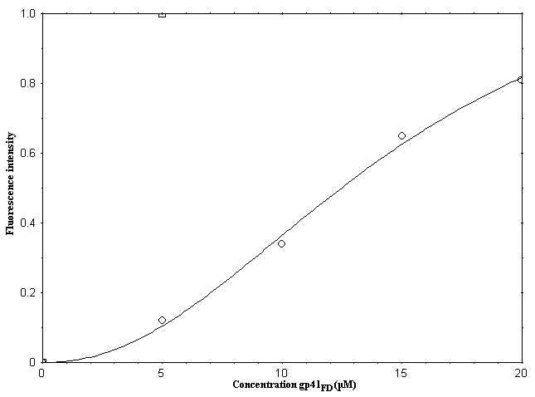FIG 3.3a
Fluorescence changes observed when FPE-labelled T lymphocytes were exposed to increasing concentrations of HIV-1 gp41_{FD}. Figure shows data from titration of human T cells with gp41_{FD} (circles) in sucrose buffer (280mM, pH 7.5. The solid line shows the sigmoidal fit (y = ax^c / (b^c + x^c)), where a = extent of the binding,
b = dissociation constant and c = Hill coefficient.

3.4 Arrhenius analysis of the gp41_{FD} binding reaction
The Arrhenius plot is used to determine the activation energy (E_{A}) of a reaction. To prove that the binding of gp41_{FD} to membranes is facilitated by receptors (e.g. CD4, CCR5, CXCR4), data was obtained for the binding of the peptide to both Jurkat T lymphocytes and synthetic PCPS liposomes. It has been shown that gp41_{FD} can bind to liposomes, regardless of the absence of any receptors [Cladera et al, 2001]. If cell receptors do in fact assist in the binding of gp41_{FD} to T lymphocytes, then it would be expected that the E_{A} for this reaction would be lower (i.e. receptors ‘catalyse’ the binding of the peptide to the cell membrane).

3.41 Analysis of the binding of gp41_{FD} to Jurkat T lymphocytes
30μM of gp41_{FD} was added to a suspension of approximately 10,000 FPE-labelled Jurkat T cells per ml in sucrose buffer (280mM, pH 7.5) at varying temperatures and the resulting change in fluorescence intensity analysed (See Appendix for data). Rate data was obtained for the binding reaction of the fusion peptide to cells (using the SX18MV software) and plotted in an Arrhenius plot (See Figure 3.41a). As the concentrations for reactants remained the same throughout each experiment, it was unnecessary to calculate the rate constant (K) for each reaction. Consequently, ln(Rate) was used instead of lnK.
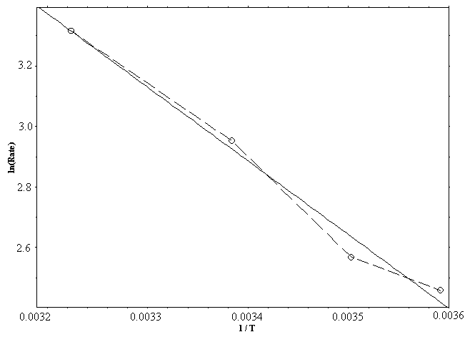FIG 3.41a
Arrhenius plot showing ln(Rate) plotted against 1 / T (in Kelvin). Data was obtained from the binding reaction of gp41FD to Jurkat T lymphocytes. The equation of the fit line (solid) is y = -2434x + 11.2. The activation energy for the reaction is therefore 293 J. mol⁻¹.

As the data did not lie in a straight line, a best-fit line was plotted. The r² value for this line was 0.985 and the standard error was 0.068, implying that the fit is quite good. As the gradient of the line is equal to E_{A} / R (gas constant), it was calculated that the activation energy for the reaction is 293 J. mol⁻¹.

3.42 Analysis of the binding of gp41_{FD} to synthetic PCPS liposomes
30μM of gp41_{FD} was added to a suspension of approximately 10,000 FPE-labelled PCPS liposomes per ml in Tris buffer (10mM, pH 7.4) at varying temperatures and the resulting change in fluorescence intensity analysed (See Appendix for data). Rate data was obtained and plotted in an Arrhenius plot (See Figure 3.42a).
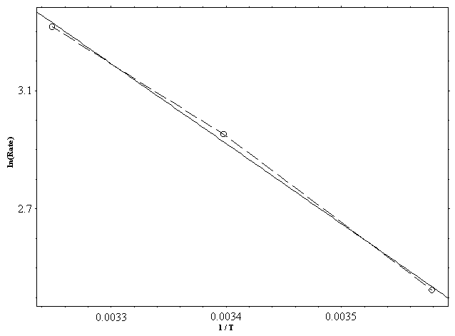FIG 3.42a
Arrhenius plot showing ln(Rate) plotted against 1 / T (in Kelvin). Data was obtained from the binding reaction of gp41_{FD} to PCPS liposomes. The equation of the fit line (solid) is y = -2709x + 12.1. The activation energy for the reaction is therefore 326 J. mol⁻¹.

A best-fit line was plotted, with an r² value of 0.997 and a standard error of 0.026 i.e. a very good fit. It was calculated that the activation energy for the binding of gp41_{FD} to synthetic PCPS liposomes was 326 J. mol⁻¹.

3.5 Arrhenius analysis of the gp41_{FD} insertion reaction
Following the binding of gp41_{FD} to a membrane a fusion process occurs, whereby the fusion peptide inserts itself into the lipid bilayer and disrupts it. As a consequence of this, the HIV-1 virus can fuse its envelope membrane to that of its host and introduce its genome.
To determine the nature of this insertion reaction, rate data for the insertion of gp41_{FD} into both Jurkat T lymphocytes and PCPS liposomes was obtained (See Appendix for data). This data was plotted in Arrhenius plots to obtain the activation energy (E_{A}) for the insertion reaction. If cell receptors assist the insertion of the fusion peptide into cells (as well as the binding reaction), it would be expected that the E_{A} for Jurkat T cells would be lower than that for synthetic liposomes.
The rate data for the insertion reaction of gp41_{FD} to Jurkat T lymphocytes (See Figure 3.5a) and to PCPS liposomes (See Figure 3.5b) was plotted on Arrhenius plots. Best-fit lines were fitted to both Arrhenius plots. The best-fit line for the insertion of gp41_{FD} into Jurkat T lymphocytes had an r² value of 0.983 and a standard error of 0.032, implying that it was a reasonably good fit. It was calculated that the E_{A} of this insertion reaction is 130 J. mol⁻¹. The best-fit line for the insertion of the fusion peptide into PCPS liposomes had an r² value of 0.997 and a standard error of 0.004, implying that it was a very good fit. The E_{A} for this insertion reaction was calculated to be 49.5 J. mol⁻¹.

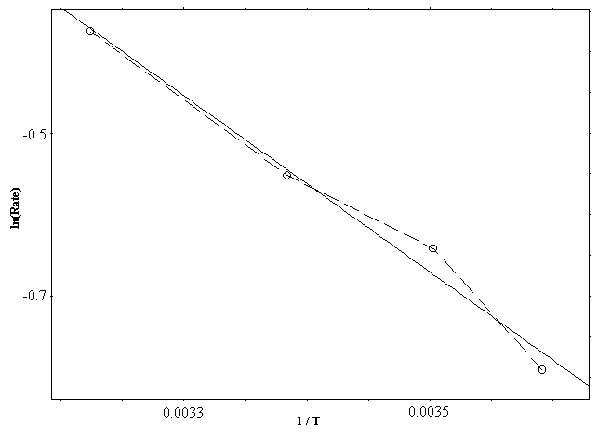FIG 3.5a
Arrhenius plot showing ln(Rate) plotted against 1 / T (in Kelvin). Data was obtained from the insertion reaction of gp41_{FD} to Jurkat T lymphocytes. The equation of the fit line (solid) is y = -1083x + 3.12. The activation energy for the reaction is therefore 130 J. mol⁻¹.

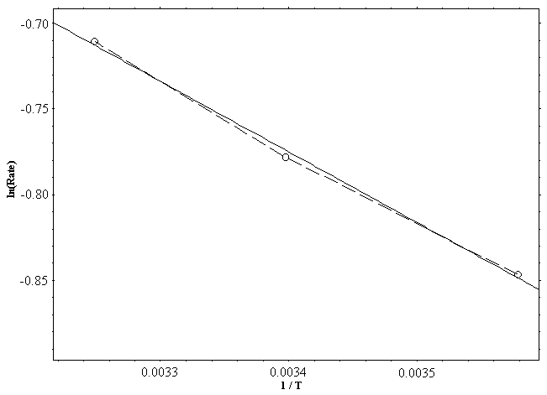FIG 3.5b
Arrhenius plot showing ln(Rate) plotted against 1 / T (in Kelvin). Data was obtained from the insertion reaction of gp41_{FD} to PCPS liposomes. The equation of the fit line (solid) is y = -411x + 0.613. The activation energy for the reaction is therefore 49.5 J. mol⁻¹.

