INTRODUCTION

1.1 The classification of HIV and AIDS
In the early 1980s, doctors first came across young men suffering from such rare conditions as Kaposi’s sarcoma (a skin cancer) and pneumonia caused by the bacteria pneumocytosis carinii [kahn.uicomp.uic.edu]. These conditions were eventually named AIDS (Acquired Immune Deficiency Syndrome). Three research groups led by Gallo (National Cancer Institute), Montagnier (Pasteur Institute, France) and Levy (University of California) claimed to have identified retroviruses that were thought to cause AIDS. These viruses named human T-lymphotrophic virus III, lymphoadenopathy-associated virus and AIDS-related virus respectively, were deemed to be the same thing. The molecule was subsequently renamed Human Immunodeficiency Virus (HIV). It was discovered that the virus was related to the simian form of HIV [Daniel et al, 1985]. An HIV variant was soon discovered and named HIV type 2 (HIV-2), with the classic virus classified as HIV-1 [Guyader et al, 1987]. The existence of HIV-2 had actually previously been suggested by scientists at the Harvard Institute in 1986, but later disputed by researchers from the same group. By the late 1980s, the three related retroviruses had been identified and classified, and work was underway to find a cure for this devastating condition.

1.2 AIDS and its clinical implications
In order for a patient to contract HIV, the virus must be transmitted into their bloodstream through a number of methods. Although the virus is present in blood, urine, semen, vaginal and anal secretions, saliva, breast milk and faecal waste, it only appears that contact with blood, semen and vaginal secretions can cause the transmission of HIV. The most common causes of passing on the virus are therefore sexual contact, the birth of an infant and exposure to contaminated syringes and needles. To prevent infection through the receipt of infected donated blood, all blood is tested for antibodies to HIV-2 (since June 1990) and HIV-1 (since October 1995) [Tavanyar, 1992].
The early symptoms of AIDS include mild fever, tonsillitis, weight loss, enlarged lymph glands and excessive sweating. In the later stages of AIDS, opportunistic infections may strike. These include pneumonia, tuberculosis, cytomegalovirus (infecting eyes, lungs and gut) and a number of parasitic and fungal infections. Kaposi’s sarcoma (a rare skin cancer) may also be seen [hcd2.bupa.co.uk].
The clinical stages of the progression of HIV infection can be divided into 4 stages [Stevens & Lowe, 1995]:
1. Primary infection (seroconversion)
2. Asymptomatic phase (incubation period)
3. AIDS-related complex
4. AIDS
During seroconversion, the antibodies to HIV are undetectable in the blood. Antibodies are present during the incubation period, and the patient is infectious. This stage can last for up to 10 years. The number of infected CD4+ cells increases during the AIDS-related complex stage. The number of functional T-lymphocytes falls to around 400 cells/μl (usually 1000cells/μl). The final stage involves complete immunodeficiency, characterised by infection with one or more opportunistic illnesses.

1.3 The structure of HIV
The HIV virus is one of a number of enveloped retroviruses. The virus is approximately 100-150nm in diameter, and exists in a variety of shapes. The envelope consists of a lipid rich membrane, studded with 70-80 protrusions, approximately 15nm in diameter and 9nm high [Gelderblom et al, 1987]. These are known to consist of two lipoproteins, gp41 (stem) and gp120 (protruding cap). The complex of gp41 and gp120 is called env protein. Inside the envelope is the outer core of the virion, also known as the viral matrix. This is made of the protein p17. The inside of the virion consists of two strands of RNA and three enzymes - p51 (a reverse transcriptase), p11 (a protease), and p32 (an integrase). These are all encased in the viral capsid, made of the inner core protein p24 (See Figure1.3a).
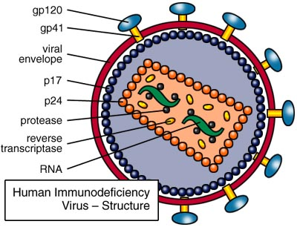
FIG 1.3a
The structure of the HIV virus
(www.avert.org)

1.4 The genome of HIV-1
The genome of HIV-1 is 9.8kb, and consists of nine genes. The three main genes are the gag gene, which codes for the structural proteins p17 and p24; the env gene, which codes for the lipoproteins gp431 and gp120; and the pol gene, which codes for the three HIV enzymes. The other genes are the tat, rev and nef genes (regulatory) and the vif, vpr and vpu genes (auxiliary). These genes code for proteins that control either the HIV infection of host cells, the reproduction of the virions or the causation of disease. The genome is flanked on both the 5’ and 3’ ends by long terminal repeats (LTRs) (See Figure 1.4a).
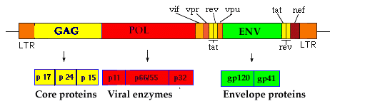FIG 1.4a
The genome of HIV-1
(Adapted from biology.fullerton.edu)

1.5 The life cycle of HIV-1
The replication cycle of the HIV-1 virus has been divided into 9 stages - binding and fusion; infection; reverse transcription and DNA synthesis; integration; viral transcription; assembly; budding; release and maturation (See Figure 1.5a).
The cycle begins when the HIV virion comes into contact with the surface molecule Cluster Designation 4 (CD4) on T lymphocytes. The gp120 on the surface of the virion binds to CD4 and membrane fusion occurs, allowing entry of the viral core into the host cell. The capsid is broken down and the RNA strands are released. Viral reverse transcriptase converts the RNA into DNA, which can then be integrated into the chromosomes of the host, under the action of p32 integrase. Host mRNA is formed (containing the viral genome), and transported from the nucleus to the endoplasmic reticulum, where proteins (including those of the virus) are synthesised. Assembly of the newly formed proteins and viral RNA into immature virions occurs, and the subsequent viral particle is expelled from the cell. Cleavage of the core proteins and enzymes by the p11 protease results in the maturation of the HIV viral particle [Schoub, 1994].

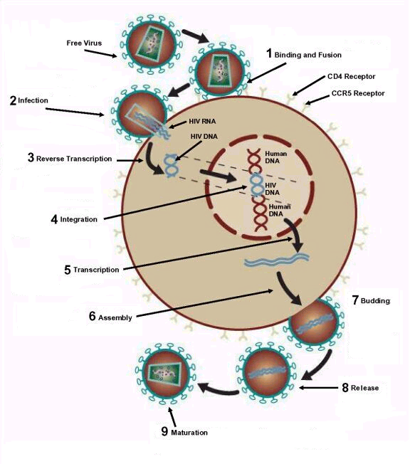
FIG 1.5a
The life cycle of the HIV-1 virus
(Adapted from www.aids.org)

1.6 The envelope glycoproteins
The two envelope proteins gp41 and gp120 are present as a non-covalent complex in the outer envelope of the HIV-1 virus. These two proteins are involved in membrane binding and fusion i.e. the first step of the viral life cycle. Gp120 is an external protein concerned with binding to the host cell, whilst gp41 is a membrane spanning protein that initiates the fusion of the virus and host cell membranes. The carboxyl tail of gp41 is inside the viral envelope (See Figure 1.6a).
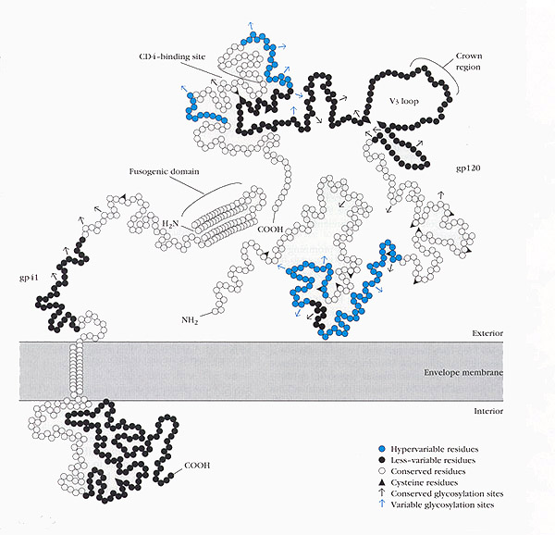
FIG 1.6a
gp120 and gp41 at the viral envelope membrane
(Printed with permission from Prof. P. O’Shea)

The formation of gp120 and gp41 occurs in the Golgi apparatus, when an initial glycoprotein (gp160) is cleaved by proteases [Kowalski et al, 1987].
The core of gp41 consists of a triple-stranded, parallel, α-helical coiled coil (N-terminus), and the outer layer consists of three anti-parallel α-helices (C-terminus) - 6 helices in total [Chan et al, 1999]. Gp41 also has a protolytically resistant ectodomain, which exists in the fusion-competent conformation of the protein [Weissenhorn et al, 1997]. This ectodomain is largely responsible for the trimerisation of gp41 [Shugars et al, 1996].
The core of gp120 has an inner and outer region, with a β sheet. There are five variable regions (named V1-5), one of which (V3) determines the specificity for chemokine receptors. Two other variable loops (V1 and V2) modulate the activity of V3 [Hoffman & Doms, 1999].

1.7 Binding and fusion of HIV-1 to human T lymphocytes
HIV-1 binds to T lymphocytes primarily via the CD4 glycoproteins on the cell surface of human T lymphocytes [Dalgleish et al, 1984]. It is also known that the chemokine receptors CCR5 and CXCR4 are also important co-receptors for HIV-1 [Berger, 1997].

1.71 The mechanism of binding of HIV-1 to human T lymphocytes
It has been shown that the affinity of CD4 for monomeric gp120 is high, but the affinity for oligomeric gp120 is a lot lower [Ugolini et al, 1999]. It would appear that the formation of the gp41-gp120 oligomer affects the accessibility of the CD4 binding site - reductions in affinity have seen to be reduced by up to three orders of magnitude [Fouts et al, 1997]. This drop in affinity is also apparent for other ligands of gp120, in that most neutralising monoclonal antibodies appear to bind with much higher affinity to monomeric rather than oligomeric gp120 [Ugolini et al, 1999]. It is suggested that the binding site for CD4 is hidden by the V1 and V2 variable loops of gp120 in its oligomeric conformation [Wyatt & Sodroski, 1998]. One possibility is that gp120 switches between two conformations - open (where the binding site for CD4 is exposed) (See Figure 1.71a), and closed (where the V1 and V2 loops act to hide the binding site) (See Figure 1.6a). A bias towards the closed state whilst in an oligomeric form would explain why the affinity decreases. This bias may arise in order to protect the virus from attack by antibodies [Moore & Binley, 1998].
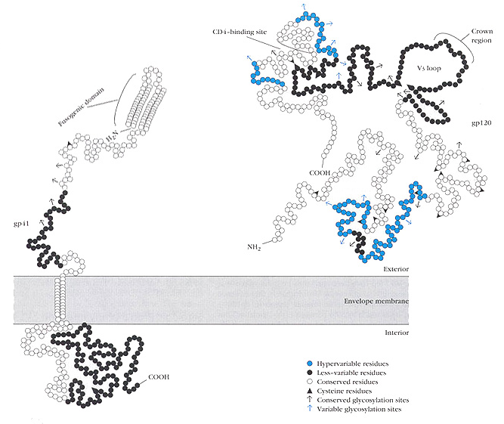FIG 1.71a
The ‘open’ conformation of gp41/gp120. Notice that the CD4 binding site is exposed.
(Printed with permission from Prof. P. O’Shea)

HIV-1 can also bind to human T lymphocytes via co-receptors. The CCR5 receptor is used during the early transmission and asymptomatic stages of infection, whilst the CXCR4 receptor is used at the later stages [Berger, 1997]. There is a phenotypic switch between the use of the CCR5 receptor (R5 virus) and CXCR4 receptor (X4 virus) - the progression from initial HIV-1 infection to AIDS can be predicted using this switch, although the mechanism is not yet fully understood [Berger, 1997].
An early study in murine cell lines transfected with human CD4 suggested that HIV-1 attachment does not require the presence of both CD4 and co-receptors [Maddon et al, 1986], although this data may have been biased (possibly due to contamination with monomeric gp120). More recently, however, it has been shown that CCR5 may be important for HIV-1 attachment if the levels of CD4 are low [Kozak et al, 1997].
Other components, such as heparans, have also been implicated in virus-cell interactions [Roderiquez et al, 1995].

1.72 The role of chemokine co-receptors in viral binding
The most important known co-receptors for the HIV-1 virus are the CCR5 and CXCR4 receptors. These bind to the V3 loop of gp120. Macrophage-tropic viruses are known to enter cells using a pathway involving the CCR5 receptor (found on macrophages and primary T lymphocytes), whilst T-cell-tropic viruses involve the CXCR4 receptor (found mainly on primary T lymphocytes and transformed T-cell lines). Due to co-receptor specificity, it appears that there is a limit on the types of cell that different HIV strains can infect. It has been shown that the CCR5 receptor is mainly used during the early stages of HIV infection, with the CXCR4 receptor used later [Choe, 1998].

1.73 The mechanism of fusion of HIV-1 to human T lymphocytes
Once gp120 binds to a T lymphocyte, the gp120-gp41 oligomer undergoes conformational changes. The active form of gp41 is exposed, and fusion of the viral and cellular membranes can take place [Weissenhorn et al, 1999]. It is thought that the fusion event involves the insertion of a hydrophobic region of gp41 into the host cell membrane [Hernandez et al, 1996]. (A similar region exists in the protein gp32 of simian immunodeficiency virus [Cladera et al, 1999].) This hydrophobic region, referred to as the gp41 fusion domain (gp41_{FD}) (See Figure 1.73a), is located at the N-terminus of gp41 [Gallaher, 1987].
FIG 1.73a
A helical wheel representation of gp41_{FD}. The helix is a typical right-handed helix, consisting entirely of hydrophobic residues (i.e. is present within the membrane of HIV-1). The FLGFL motif (at residues 9-13) is conserved throughout HIV strains, and is thought to have a role in the functional organisation of the gp41_{FD} [Pritsker et al, 1999].

It has been shown that a dimeric gp41_{FD} interacts with phospholipid membranes, although this work was done in synthetic phosphatidylcholine membranes, and does not reflect the true interaction between the virus and T lymphocytes in vivo [Cladera et al, 2001]. In fact, it appears that a trimeric peptide complex is the most stable membrane-associated structure in T lymphocytes [Weissenhorn et al, 1999]. Three subunits of gp41 form a six-helical bundle, which wraps around a parallel, triple-stranded, α-helical coiled coil (from the gp41 fusogenic ectodomain at the N-terminus). This wraps around the three C-terminal α-helices in an anti-parallel manner [Kliger et al, 2000]. The fusogenic peptide inserts into the host cell membrane, where the gp41 molecule where the cellular and viral membranes can be brought close together [Weissenhorn et al, 1997]. A fusion event occurs and the virus releases its genetic material into the cell.

1.74 Other factors influencing binding and fusion
When a Jurkat T cell line (where the cells have no IL-8 receptors [Jones et al, 1997]) is treated with either interleukin 8 (IL-8) or heparatinase, the interaction between gp41_{FD} and the cell membrane is eliminated [Cladera et al, 2001]. A similar experiment in phospholipid membranes had no such effect, suggesting that IL-8 does not bind directly to gp41_{FD} and prevent its binding. Inhibition must therefore occur another way. As the Jurkat cell line contains no IL-8 receptors, it is hypothesised that IL-8 may bind to heparan sulphate, which is present on the cell surface membrane of T lymphocytes [Webb et al, 1993]. It has also been suggested that gp120-gp41 also interacts with heparan sulphate in a similar manner [Roderiquez et al, 1995]. This hypothesis is consistent with results that show a large reduction in gp41_{FD} binding to T cells when heparan sulphate is removed from the cell surface [Cladera et al, 2001]. It has also been indicated that soluble heparan sulphate competes with gp41_{FD} and does not enhance its membrane binding. Heparin also interacts with gp41_{FD}, but seems to have no effect on binding to the membrane [Cladera et al, 2001]. As it is evident that gp41_{FD} interacts with synthetic phospholipid membranes in a similar manner to its interactions with T lymphocyte membranes, it appears that heparan sulphate actually enhances viral fusion to the host cell membrane. However, an anomaly arises in that gp41_{FD} binding to T cells is abolished when heparan sulphate binding sites are blocked (by competitive inhibition with IL-8 and soluble heparan sulphate). One possible solution to this is that the T cell membrane area available for viral binding is much lower than that offered by the synthetic membranes. Heparan sulphate binds to gp41_{FD} and brings it closer to the cell membrane [Cladera et al, 2001] i.e. the heparan sulphate can promote the formation of a gp41_{FD} trimer instead of a dimer, although the soluble heparan sulphate has no such effect [Cladera et al, 2001].
It appears that the angle at which gp41_{FD} inserts into the membrane is an important factor in its ability to cause viral fusion [Martin et al, 1996]. The oblique angle at which the peptide is inserted can disturb the packing of the membrane bilayer by straining the membrane and favouring the formation of inverted phases [Martin et al, 1996]. (This evidence supports a similar observation in the interaction between SIV fusion peptides and cell membranes [Martin et al, 1996].) It is thought that the interaction of SIV and influenza fusion peptides with membranes may also act by this method of ‘phase destabilisation’ [Epand et al, 1994a+b].
In summary, viruses can fuse to target cells by inserting a fusion peptide into the cell membrane, thus disrupting the bilayer and enabling the viral particle to enter.

1.8 Membrane surface charge
An electric field is present on the surface all cell membranes. This is as a result of the charged interface that exists between the phospholipid membrane phase and the aqueous electrolyte phase of a cell surface. Ions move between these two phases, resulting in a potential difference. The membrane surface potential (Ψ) causes the distribution of ions at the cell surface to be uneven. Combining the Henderson-Hasselbach equation and equations from the theory of electrostatics gives a new equation:
pK_{S} = pK_{B} + Ψ

Where pK_{S} is the pK at the membrane surface, and pK_{B} is the pK in the bulk aqueous phase.

This equation shows that the pK of an acidic group at the membrane surface differs from the pK of the same group in the bulk aqueous phase. Subsequently, this infers that at a constant bulk phase pH (i.e. constant pK_{B}), any change in the membrane surface potential (Ψ) affects the protonation state of any acidic group at the membrane surface [Wall et al, 1995b].

1.9 Methods of characterisation of interactions between virus and cell
There are a number of methods used to characterise the interactions occurring between a virus and its target cell membrane. Radioactive labeling or the conjugation of viral peptides to an indicating chromophore [Cladera et al, 1999] are two such examples. Unfortunately, these two methods are unreliable. Firstly, no kinetic data can be accessed from the radioactive assay. In the case of chromophoric conjugation, it is thought that such modification may affect the viral peptide’s interaction with the cell surface membrane. However, a novel fluorescence-based technology is a new option. Interactions between the virus and the cell can be measured in real-time using a spectrometer.

1.91 Fluorescein phosphatidyl ethanolamine (FPE)
Fluorescein phosphatidyl ethanolamine (FPE) can be used to label cells in a virtually non-invasive manner. The phosphatidyl ethanolamine tail is hydrophobic, and inserts into the cell membrane (See Figure 1.91a) with minimal disruption, due to the small quantities of FPE required.
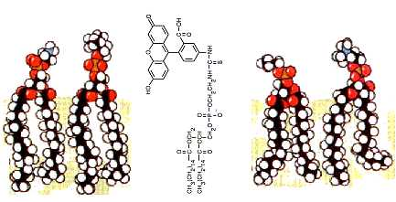
FIG 1.91a
The insertion of fluorescein phosphatidyl ethanolamine (FPE) into the lipid bilayer, showing the penetration of the membrane by the hydrophobic tail of FPE
(Printed with permission from Prof. P. O’Shea)

As previously described, the equation pK_{S} = pK_{B} + Ψ demonstrates that a change in the electrostatic surface potential of a membrane (Ψ) affects the protonation state of acidic molecules at the membrane surface under conditions of constant bulk phase pH. FPE is such an acidic molecule, and fluoresces when the Ψ changes. The interaction of a positively charged molecule (e.g. Ca²⁺) with the membrane leads to an increase in fluorescence, whilst an interaction with a negatively charged molecule (e.g. bovine serum albumin) leads to a decrease of fluorescence [Wall et al, 1995b]. The interaction between gp41_{FD} and cell membranes can therefore be measured using FPE-labeled membranes and spectrometric analysis techniques [Cladera & O’Shea, 2001].

1.10 Membrane rafts
There are many lipid ‘microdomains’ present on the plasma membrane of eukaryotic cells, asymmetrically distributed over both the inner and outer leaflet of the lipid bilayer. These microdomains on the exoplasmic side (i.e. outside the cell) consist of sphingolipids and cholesterol, and are called lipid ‘rafts’ [Popik et al, 2002]. It has been shown that these rafts are involved in a number of processes at the membrane surface, including membrane trafficking and signal transduction. A number of cell receptors are recruited to detergent-resistant membrane rafts, including the CD4 [Millan et al, 1999] and CCR5 [Manes et al, 1999] receptors. However, the distribution of these two receptors (and the CXCR4) receptor in T cell lipid rafts is not fully understood. Recent studies using immunogold electron microscopy have shown that ‘microclusters’ of CD4 and chemokine receptors (i.e. CCR5 and CXCR4) are within 100nm of each other, which suggests that there may be some degree of co-localisation in rafts [Singer et al, 2001]. It has been shown that the budding of many viral particles, including HIV-1 (from infected T lymphocytes) takes place in rafts. In fact, proteins and glycolipids present in rafts may be incorporated into the budding HIV-1 particles [Nguyen & Hildreth, 2000].
It has been suggested that two glycosphingolipids present in membrane rafts – Gb3 and GM3 – promote the entry of HIV-1 isolates into T lymphocytes [Hug et al, 2000]. However, more recently it has been demonstrated that HIV-1 entry into T cells is independent of the localisation of CD4 and CCR5 receptors to membrane rafts [Percherancier et al, 2003]. These microdomains clearly have some role in the entry of HIV-1 into human T cells, although it does not appear that the process is dependent on the presence of such domains.

1.11 Aims of experiments
The binding and fusion of HIV-1 to T lymphocytes may be temperature dependent. In this project, both synthetic membranes and T cell membranes will be labeled with FPE. The membranes will be infected with gp41_{FD}, and the subsequent change in fluorescence analysed using stopped-flow technology. Temperature will be varied to observe if this has an effect.
The information gained will give insight into the method of infection of cells by HIV-1, and could potentially be used to identify possible drug therapies or vaccines against HIV and the progression of AIDS.

